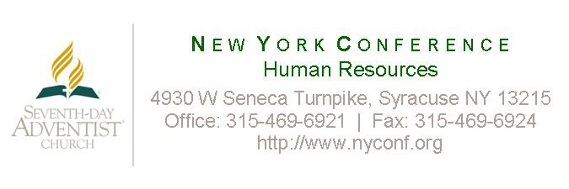
Application Form
New York Conference is a religiously-qualified Equal Opportunity Employer, with the right to prefer Seventh-day Adventists in hiring. It is the policy of New York Conference to recruit and promote all job classifications on the basis of merit, qualification, competence, attitude and spiritual commitment. No aspect of employment shall be influenced by race, color, national origin, sex, age or handicap. Your application will be kept on file for 60 days. If you want to be considered for employment after 60 days from the date of this application you must complete and submit a new application. PLEASE PRINT CLEARLY– Complete all sections, even if resume is submitted.
Position applied for_____________________________________Location_____________________________Date___________________
Last Name___________________________________ First___________________________ Middle__________________________
Address__________________________________________________________________________ Home Phone ____________________
City__________________________________ State____________ Zip______________ Cell Phone ____________________________
Are you a member of the Seventh-day Adventist Church? Yes No Pastor’s Name_______________________________________
Church Membership______________________________________Address__________________________________________________
EDUCATION
Complete the following for each school attended. (High School and above)

School (City & State) Curriculum or Major Degree Completed
________________________________ _________________________________ ______________________
________________________________ _________________________________ ______________________
________________________________ _________________________________ ______________________
Trade, Technical or Business School Course of Study Certificate Completed
________________________________ _________________________________ ______________________
________________________________ _________________________________ ______________________
SKILLS & ABILITIES
Microsoft Word _________ Beginner Intermediate Advanced Proficiency Unknown
Excel _________ Beginner Intermediate Advanced Proficiency Unknown
Outlook _________ Beginner Intermediate Advanced Proficiency Unknown
Other _____________________________ Beginner Intermediate Advanced
Other _____________________________ Beginner Intermediate Advanced
Typing __________ wpm

Do you speak, read or write any languages other than English? If so please identify proficiency levels in writing, speaking, and reading.
_______________________________________________________________________________________________________________
_______________________________________________________________________________________________________________
EMPLOYMENT
List most recent first
Dates | Employer, Address & Phone | Job & Major Duties | Reason for Leaving
From: |  | Title:
 |  | Duties:
To: |  |  | Immediate Supervisor
Dates | Employer, Address & Phone | Job & Major Duties | Reason for Leaving
From: |  | Title:
 |  | Duties:
To: |  |  | Immediate Supervisor
Dates | Employer, Address & Phone | Job & Major Duties | Reason For Leaving
From: |  | Title:
 |  | Duties:
To: |  |  | Immediate Supervisor
Dates | Employer ,Address & Phone | Job & Major Duties | Reason For Leaving
From: |  | Title:
 |  | Duties:
To: |  |  | Immediate Supervisor
ADDITIONAL INFORMATION
May we contact your current employer? YES NO
If hired, can you provide satisfactory proof of identity and legal right to work in the U.S. as required by law? YES NO
Have you ever been convicted of or pled guilty to a criminal charge? YES NO (If yes, attach a detailed explanation. The existence of a criminal record does not constitute an automatic bar to employment)
Are you able to perform the essential functions of the position for which you are applying with or without reasonable accommodation?
YES NO
EMERGENCY CONTACT
Name _________________________________________________ Relationship ________________________________________
Phone (Day/Work) _____________________________________ Phone (Cell) _________________________________________

CERTIFICATION OF APPLICATION INFORMATION
I certify that all of the information on this employment application and any resume or exhibit is true, correct and complete. I have not withheld any information requested on this application. I understand that false, misleading, incomplete or omitted information on this application or my resume will result in disqualification for employment or, if I am hired, dismissal from employment. I authorize the employing organization and its agents to confirm information supplied on this application and my resume and to investigate my suitability for employment. I agree to furnish additional information if requested. I release all parties and persons from any claims, liabilities and damages that may result from requesting or furnishing information about me to employing organizations, as well as from using such information in considering my employment application. I understand that if employed I must complete an I-9 form and provide satisfactory proof of my identity and legal authority to work in the U.S. If employed, I agree to conform to the policies and standards of the employing organization. I understand that no one other than the conference administrator or designee is authorized to enter into any employment agreement for any specific time period, or make any agreement contrary to the foregoing.
SIGNATURE OF APPLICANT________________________________________________________ DATE____________________________

