New York Conference Zero Tolerance Policy
All of the employees, constituents and visitors of the New York Conference have the right to expect a place of employment that is free from behavior that can be considered harassing, abusive, disorderly, or disruptive. Any violent behavior or behavior that creates a climate of violence, hostility, or intimidation will not be tolerated, regardless of origin. Every Conference employee and institution is encouraged to take proactive measures to minimize the potential for violent acts.
THE NEW YORK CONFERENCE IS COMMITTED TO MAINTAINING A WORKPLACE THAT IS FREE FROM VIOLENCE AND/OR THREAT OF VIOLENCE. THERE WILL BE ZERO TOLERANCE OF ACTS OR THREATS OF VIOLENCE IN OUR WORKPLACE, CHURCHES, SCHOOLS AND ALL OUR ASSOCIATED INSTITUTIONS.
This policy includes, but is not limited to, the following behaviors and situations:
- Violent or threatening physical contact (fights, pushing, and physical intimidation.)
- Direct or indirect threats
- Threatening, abusive or harassing phone calls
- Brandishing of a weapon (eg. firearm, knife)
- Destructive or sabotaging actions against company or employees’ personal property
- Stalking
- Violation of a restraining order
- Threatening acts or abusive/profane language that leads to tension within the work environment
EMPLOYEES: Any employee who makes substantial verbal threats, exhibits threatening behavior, or engages in violent acts shall be placed on immediate administrative leave, until such time that the Conference Personnel Committee can review the situation and decide the appropriate course of action. (This response could, depending on the severity of the incident and/or other relevant considerations, include termination of employment with the New York Conference.)
Reporting Procedure (employee):
Any incident that results in placing an employee on administrative leave will be reported to the Conference Administrative Committee and forwarded to the Personnel Committee. The recommendations from the Personnel Committee will then be forwarded to the appropriate governing board and reported to the Executive Committee for final disposition.
CONSTITUENTS: Any Conference constituent, church member or visitor who makes substantial threats, exhibits threatening behavior, or engages in violent acts on New York Conference property will be asked to remove themselves from the premises immediately, and they shall not be allowed to return to the premises pending the outcome of a review by the organization’s administrative board.
Reporting Procedure (constituents):
Any incident that results in removing someone from our premises will be reported to the New York Conference Executive Secretary, along with the results of the review by the organization’s administrative board.
**Any person can report concerns or incidences, however the decision to remove someone from our premises is solely the prerogative of the local Conference representative. eg: Conference Administrators, Pastor, Principal, Camp Director, or their designee in case of their absence.

This form should be kept by the employee.

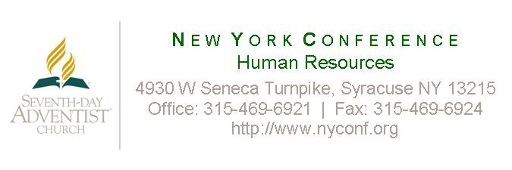
Zero Tolerance
Policy Acknowledgment

New York Conference Zero Tolerance Policy

I acknowledge receipt of the New York Zero Tolerance Policy. I understand that it is my responsibility to read this policy, and I agree to comply with its terms.

If I have questions about this policy, I will ask my supervisor or a human resources representative. I may also contact the Secretary for administration for the New York Conference.

I understand that the New York Conference is committed to maintaining an environment that is free from violence and/or threats of violence. I understand that there will be a zero tolerance policy of acts or threats of violence. As an employee, I also understand my duty to ensure that no acts or threats of violence take place in any of our churches, schools, offices or any other of our affiliated institutions.

The New York Conference will investigate complaints of violence or threats of violence and, where appropriate, take corrective action sufficient to terminate the conduct.

I understand that if I engage in violence or threat of violence while employed by the New York Conference, I will be subject to disciplinary action, up to and including termination of employment.

________________________________________
Employee Name (Please Print)

________________________________________ ________________________
Employee Name (Signature) Date

