Harassment Free Workplace Policy
New York Conference of Seventh-day Adventists

Personal Conduct – Employees of the New York Conference are to exemplify a Christ-like life and shall avoid all appearance of wrong doing. They should not engage in behavior that is harmful to themselves or others or that casts a shadow on their dedication to the Christian way of life. Employees should respect and uplift one another. Employees should never be placed in a position of embarrassment, disrespect or harassed because of their gender, race, color, national origin, age or disability. To do so would be a violation of God’s law and civil laws protecting human rights and governing work place conduct.

Sexual Harassment – Sexual harassment is a form of harassment that involves unwelcome sexual advances, requests for sexual favors or other verbal, written or physical conduct of a sexual nature when:
1. Submission to such conduct is made either explicitly or implicitly a
term or condition of an individual’s employment; or
2. Submission to or rejection of such conduct by an individual is used
as the basis of employment decisions affecting such an individual; or
3. Such conduct has the purpose or effect of unreasonably interfering
with an individual’s work performance or creating an intimidating,
hostile, or offensive working environment.

Improper Conduct – Improper conduct by the employer, co-workers and, in some instances, non-employees includes, but is not limited to:
1. Any subtle or other pressure for sexual favors, including any suggestion
that an applicant’s or employee’s giving in to or rejecting sexual advances
will have an effect on that person’s employment or terms of employment.
2. Unwelcome sexual flirtation or propositions.
3. Unnecessary or inappropriate touching of a sexual or abusive nature (e.g.
patting, pinching, hugging, repeated brushing against another person’s
body, etc).
4. Displays of sexually suggestive pictures, drawings, cartoons or objects.
5. Threats or demands for sexual favors.
6. Unwelcome or derogatory statements related to gender, race, color, national
origin, age or disability (for example, kidding, teasing, and degrading jokes, offensive comments or tricks).
7. Demeaning or degrading comments about an individual’s appearance.
8. Denying an employee the opportunity to participate in training or education
on account of gender, race, color, national origin, age or disability.
9. Limiting opportunities for promotion, transfer or advancement on account
of gender, race, color, national origin, age or disability.
10. Requiring a protected employee to perform more difficult tasks or less
desirable work assignments in order to force them to retire or resign from
employment.

Reporting Incidents – Employees who believe that they have been harassed should immediately take the following steps:
1. Make it clear that such behavior is offensive and must be stopped immediately;
and
2. Report the incident to the immediate department director or the designated
officer of the organization to whom complaints can be made. The initial
report should be followed by a written statement describing the incident and
identifying potential witnesses.

Third-party Reports – Employees who are aware of incidents of potential workplace harassment toward others are to report such incidents to their department director or the designated officer to whom complaints can be made.

Investigation – Complaints of harassment shall be promptly handled and maintained in confidence to the extent possible.

Discipline – A violation of this policy may result in discipline, up to and including dismissal from employment.

Prohibition of Retaliation – New York Conference prohibits retaliation against employees complaining of harassment.

Maintaining a Harassment-Free Environment – New York Conference recognizes its responsibility to all employees in maintaining an environment free from harassment and endeavors to prevent harassment by publishing this policy, by development of appropriate sanctions for misconduct, and by informing all employees of their right to complain of harassment.

To maintain a work environment free of harassment and to assist in preventing inappropriate workplace conduct, the New York Conference shall endeavor to take the following actions:

1. Each employee shall receive a copy of the harassment policy and
complaint procedure.
2. Each employee shall acknowledge receipt of this policy and complaint
procedure which will be maintained in the employee’s personnel file.
3. In addition to an employee’s departmental director/supervisor, the
New York Conference has designated the Secretary, Treasurer, as well as the
Director of Human Resources as individuals to whom complaints can be made.
4. Employees who make harassment complaints will not be subjected to
retaliation by supervisors or co-workers.
5. Although New York Conference urges individuals to report alleged
harassment, malicious allegations can irreparably harm an employee’s
reputation and limit his/her ability to fulfill responsibilities. Employees
who bring malicious, spiteful, false allegations of harassment will be
subject to appropriate disciplinary action.

This form should be kept by the employee.
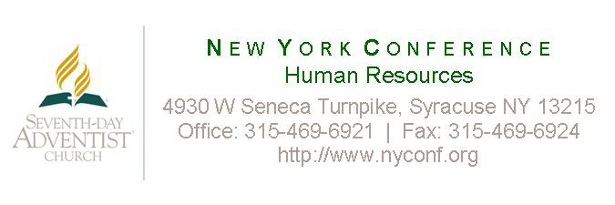
Harassment Policy Acknowledgment

I acknowledge receipt of the New York Conference’s Harassment Policy. I understand that it is my responsibility to read this policy, and I agree to comply with its terms.

If I have questions about this policy, I will ask my supervisor or a human resources representative. I may also contact the Secretary for administration for the New York Conference.

I understand that the New York Conference is an equal opportunity employer and prohibits discrimination, harassment or intimidation of any employee. If I believe I have been subjected to discrimination, harassment or intimidation, I agree to promptly notify my supervisor, or the New York Conference Secretariat office.

The New York Conference will investigate complaints of harassment, discrimination or intimidation and, where appropriate, take corrective action sufficient to terminate the conduct.

I understand that if I engage in discrimination, harassment or intimidation while employed by the New York Conference, I will be subject to disciplinary action, up to and including termination of employment.

________________________________________
Employee Name (Please Print)

________________________________________ ________________________
Employee Name (Signature) Date

